

**Database Management System**

**USER MANUAL**



**Database Management System**

**USER MANUAL**

Prepared for Martin Cleaners by the **Mavs Group**:

* Joe Cremeens
* Erik Eiler
* Shafiq Janish
* Christopher Kozeny
* John Manzo

August 2019

University of Nebraska at Omaha

**TABLE OF CONTENTS**

INTRODUCTION & OBJECTIVES 3

THE INFORMATION SYSTEM 4

Getting Started 4

Using the System 4

Data Entry, Updates, and Combo Box Lookups 5

Generating Reports 9

Filtering Reports 11

APPENDIX A: SYSTEM INSTALLATION 13

APPENDIX B: BACKUP & RECOVERY PROCEDURES 14

# INTRODUCTION & OBJECTIVES

The Martin Cleaners Database Management System is an all-in-one software application for managing the business operations of Martin Cleaners. The application is powered by Microsoft Access database software and is designed to run on the Microsoft Windows 10 operating system. The primary objective of the system is to centrally organize and archive all business data into a single application and eliminate the need for reductant data entry and manual report generation.

The application establishes permanent links between the different categories of Martin Cleaners’ business data—appointments, clients, inventory, purchases, and vendors—thus ensuring every appointment is associated with the proper client, every purchase with the proper vendor, and inventory quantities are updated as supplies are used for appointments or restocked by purchases. Additionally, the application allows Martin Cleaners to instantly generate schedules of upcoming appointments, invoices for clients, itemized purchase histories, and profit/loss reports with no need for additional data entry.

This user manual describes the steps required for installing the system, using its operations management and reporting features, backing up the system’s data, and recovering the data in the case of a system failure. The next section—The Information System—guides users with setting up and operating the system. Appendix A provides more detailed step-by-step instructions for system installation. Appendix B outlines the processes to reliably backup and recover the system.

# THE INFORMATION SYSTEM

Martin Cleaners Database Management System requires Microsoft Access to be installed on a computer running the Microsoft Windows 10 operating system.

## Getting Started

1. Using the provided installation disk, open the **MSAccessSetup.exe** file to install MS Access onto your Windows 10 computer.
2. When prompted enter the Product Key from the **AccessPK.txt** file.
3. From the disk, copy the **MartinCleanersDBMS.accdb** file onto your computer. This file is the complete application, within which all user activities occur, and all data is stored.
4. Remove the disk from the computer and open the application to begin entering data into the system.

*Note: For detailed installation instructions, refer to Appendix A.*

## Using the System

Upon launching the application, users will be presented with **Main Menu** (fig. 1). This screen provides navigation options to the application’s **Forms**, where data is entered, updated, and can be looked up, and to the application’s auto-generated **Reports**.

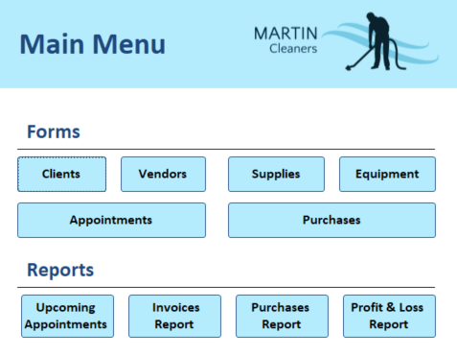  
*Figure 1: The Main Menu.*

### Data Entry, Updates, and Combo Box Lookups

Before the system can perform its intended functions, its database must be populated with business records. Once entered, these records can be viewed, updated, and searched from within their respective forms.

Figure 2 shows the **Client Form**. To enter a new client record, click the New Record button at the bottom of the form and provide the following information:

* Company Name (for commercial clients only)
* First Name, Middle Initial (optional), Last Name (for residential clients; optionally used for a commercial client’s contact person)
* Address 1 (the client’s street address where cleaning services are performed)
* Address 2 (optional additional street address information)
* City, State, Zip Code (the remainder of client’s address; five- and nine-digit zip codes are permitted)
* Phone Number (the client’s voice number; line extensions are optional)
* SMS Text (an optional field for the client’s mobile text number)
* Email (the client’s email address)

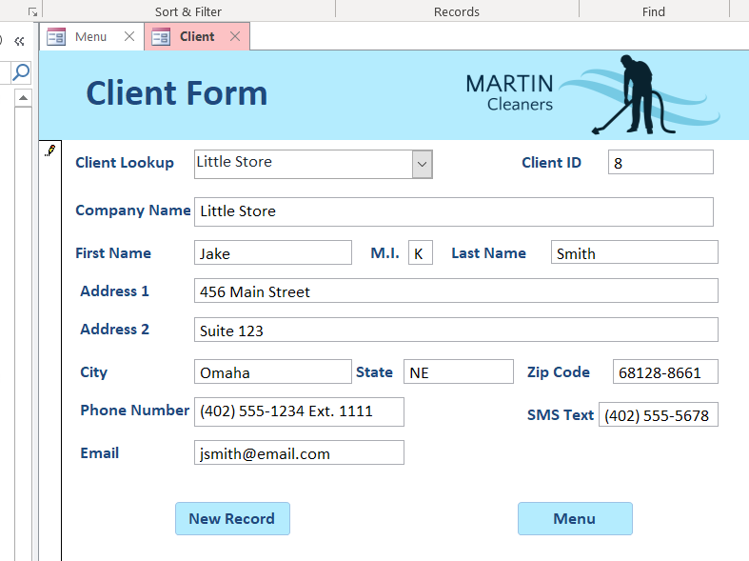

*Figure 2: The Client Form*

After entering a new client record, click the New Record button again to enter additional records or click the Main Menu button to return to the **Main Menu**.

The Client Lookup field, known as a combo box, allows for fast and accurate selection of existing client records by either Company Name or Last Name. Once looked up and displayed in the form, any existing record may be updated with new data; changes made are saved automatically.

Combo boxes are included in all forms (and the **Invoice Report**). Combo boxes alleviate the problem of erroneous data entry by providing users with a finite set of acceptable values from which to choose (fig. 3).

The Client ID field shows the unique number the system uses to keep track of all clients and ensure link between clients and appointments is never severed, even when client records are updated. Client IDs are automatically generated by the system when a new record is added and cannot be altered by system users.

**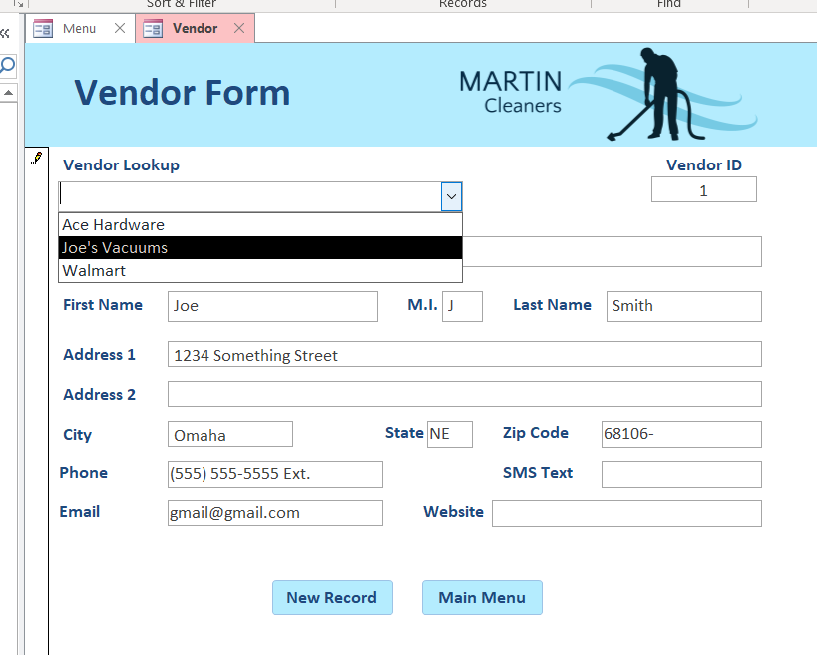 *Figure 3: Using a combo box to lookup a vendor’s company name in the* ***Vendor Form***

- - - - - - - - - -

Data entry, updates, and combo box lookups work the same way for the other five forms as they do in the **Client Form,** but some also have unique characteristics and caveats.

**Vendor Form**

This for is where vendor records are added and managed in the same fashion of client records.

**Supplies Form**

This is where cleaning supplies records are entered or updated. Supply quantities are dynamically updated when supplies are used during an appointment or restocked by a purchase—this process is detailed further in the **Purchase Form** and **Appointment** **Form** descriptions below.

**Equipment Form**

This is where equipment records are entered and updated. Each record contains the equipment item’s purchase date, warranty expiration date (optional), and indicates if the item is in operational condition and available for use. Equipment items included in new purchase records will also be added to the equipment stock as a unique record, which may then be accessed through the form’s combo box lookup.

*Note: Each equipment record depicts a single item. Only supplies, which deplete with use, have fluctuating quantity-on-hand values.*

**Purchase Form**

This is where purchase records for supplies and equipment are entered or updated. This form not only creates a new purchase record, the quantity-on-hand of existing supplies is updated when users click the Inventory Update button in the embedded subform (fig. 4). This allows users to both record purchases and update inventories without having to navigate to another form. The same supplies quantity update procedure is used in the **Appointment Form**.

*Note: A purchase cannot be created unless there are existing vendor and supplies or equipment records to associate it with.*

**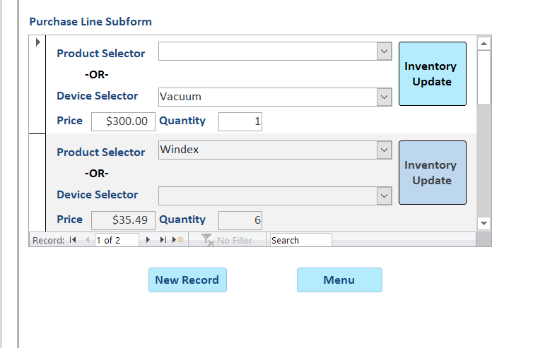  
*Figure 4: The Purchase Line subform embedded in the Purchase Form. Clicking the Inventory Update buttons will and add six units to the quanty-on-hand of Windex.*

**Appointment Form** (Fig. 5)

This is where appointment records are created or updated. Each appointment record must be associated with an existing client; thus, a Client Lookup combo box is provided at the top of the form. The same is true of supplies or equipment assigned to an appointment record. The Update Inventory button will adjust the quantity-on-hand of any supplies selected; equipment records are not affected by the update buttons.

Additionally, multiple values in each appointment record serve a dual purpose: they are also called upon in **Invoice Report** generation (described in the following Generating Reports subsection). The Service Date is also the Invoice Date, the Description and Cost values are the invoice service description and amount due.

*Note: To generate an invoice, “Is Paid” must be unchecked.*

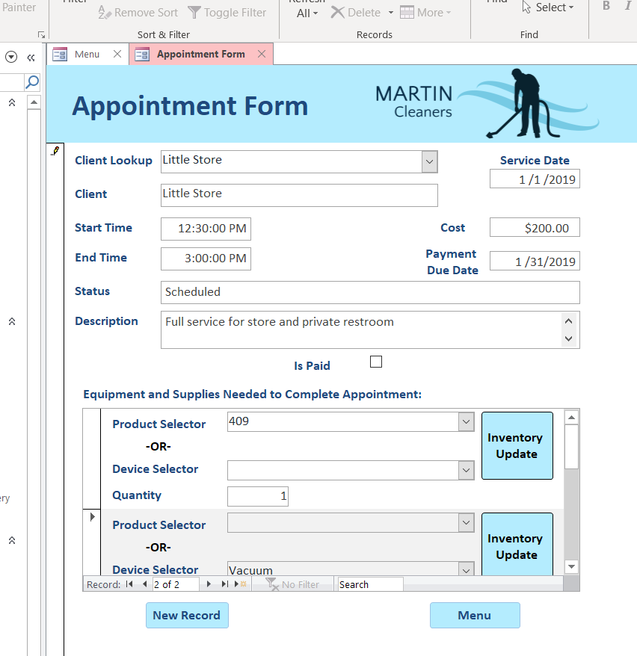  
*Figure 5: The Appointment Form*

### Generating Reports

The system can generate four different reports using data already present in the system. All reports are assessible from the **Main Menu**. Reports can be printed or saved as a PDF file from inside the application (File >> Print >> Choose Printer or Print to PDF).

*Note: The following subsection, Filtering Reports, explains how to customize reports to show only wanted information.*

**Upcoming Appointments Report** (fig. 6)

This report lists all upcoming appointments by service date and includes the appointments’ start and end times, along with the client and address location associated with appointment.

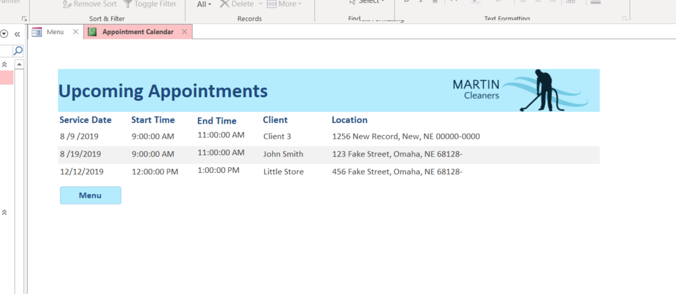  
*Figure 6: The Upcoming Appointments Report*

**Invoice Report** (fig. 7)

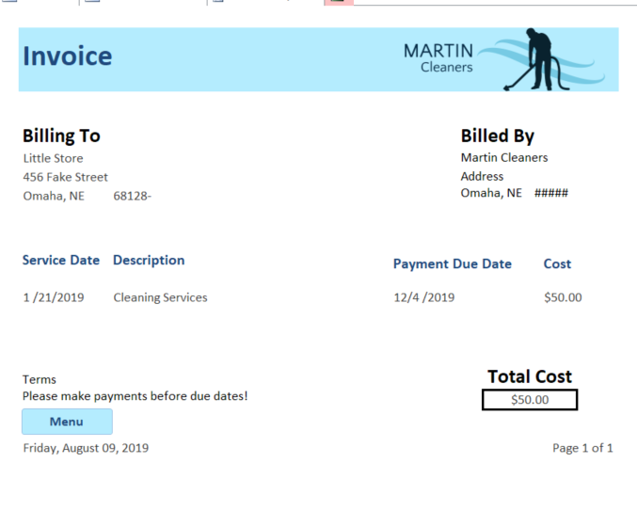This report uses information from appointment records to generate client invoices. When the Invoice Report button on the **Main Menu** is clicked, users will be presented with a combo box to select a client by company name or last name, upon which an invoice will be generated containing line items (the Description values from appointment records) for all appointment records not flagged as “Is Paid.”

*Figure 7: The Invoice Report*

**Purchase Report** (fig. 8)

This report shows records of all purchases made from vendors, including itemized listings of supplies and equipment items, the vendors’ company names, the dates of purchase, the payment due dates, and the dates the purchases were paid.

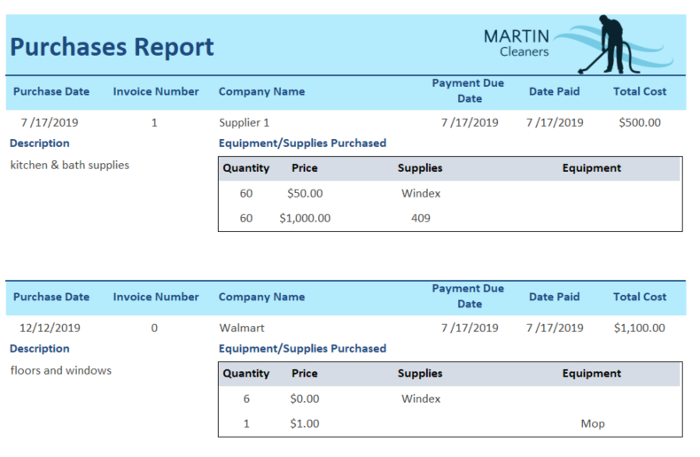  
*Figure 8: The Purchases Report*

**Profit/Loss Report** (fig. 9)

This report calculates the difference between appointment income and purchase expenses to show either a profit or loss. By default, this report includes every appointment and purchase record stored in the system.

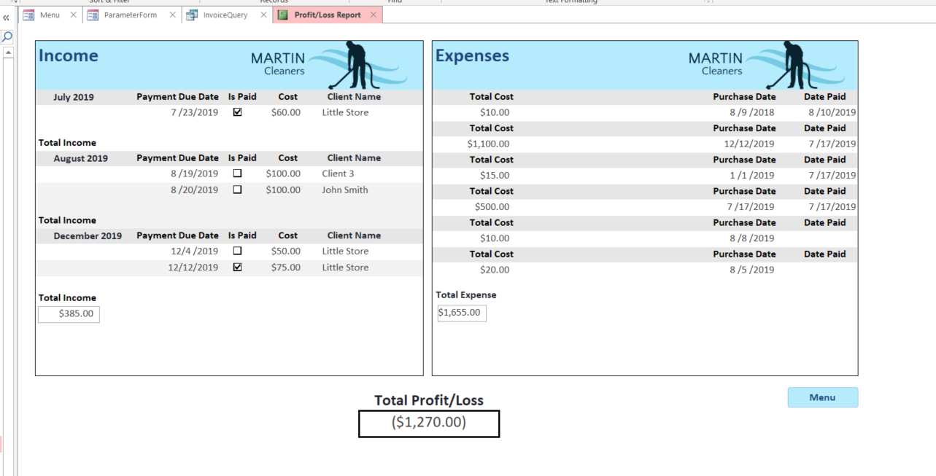  
*Figure 9: The Profit/Loss Report*

### Filtering Reports

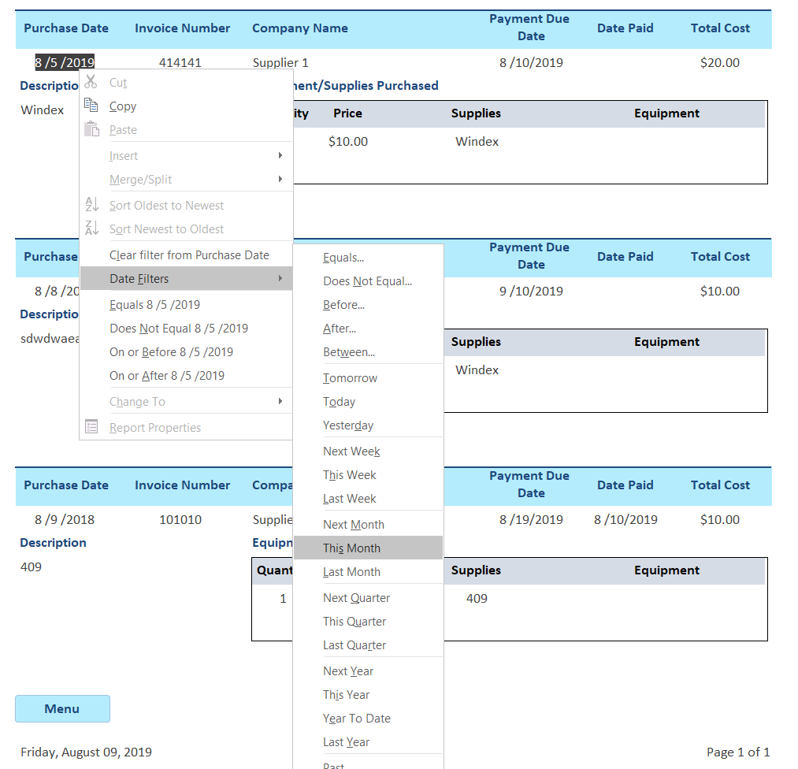Users wishing to customize reports may do with application’s filtering function. Reports can be filtered by any of the values contained within them. To access filtering options, right-click on a value, such as a company name or date, and select the desired filtering criteria (fig. 10).

*Figure 10: Filtering a Purchase Report to only show purchases made in August 2019*

**Multiple filters can be applied to drill-down even deeper. In Figure 11, a Profit/Loss Report is utilizing two filters to remove unpaid payables and receivables from the report.

|  |  |
| --- | --- |
| *Cursor* | *Cursor* |
| *Figure 11: Using multiple filters in a Profit/Loss Report* | |

To Remove filters from reports, right click on the value being filtered and chose the “Clear filter from” option (fig. 12)

**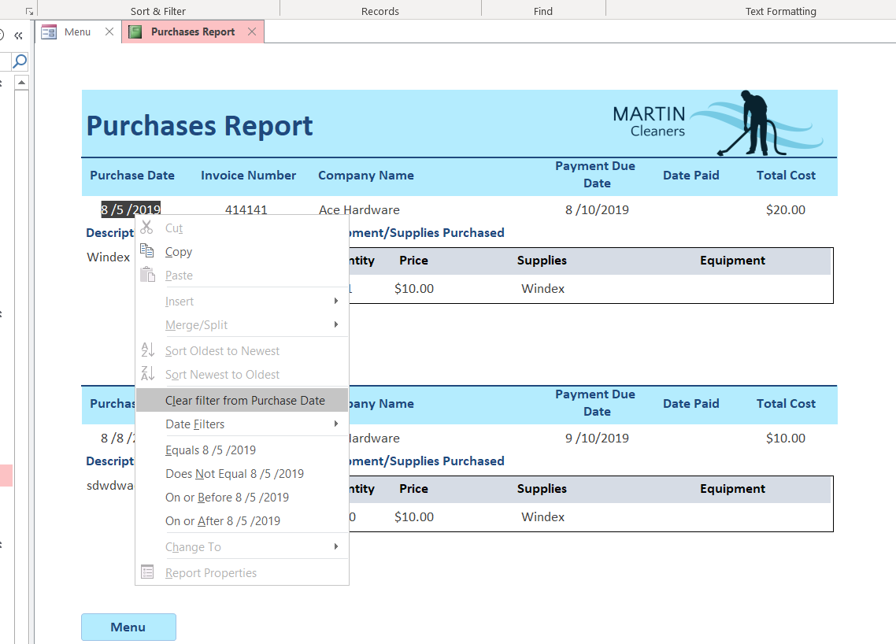  
*Figure 12: Clearing the Purchase Date filter from a Purchase Report*

Filters add immense flexibility to the system’s reports and allow users to avail themselves with only the information relevant to them at the moment. Moreover, filtering supports one the system’s key design principles: don’t delete records, manage them. After all, the business value of the system’s reports only increases as historical data is accumulated.

# APPENDIX A: SYSTEM INSTALLATION

The Martin Cleaners Database Manage System is designed to run on the Microsoft Windows 10 operating system. The proved installation disk contains the three files required to install the system:

1. MSAccessSetup.exe
2. AccessPK.txt
3. MartinCleanersDBMS.accdb

First, open **MSAccessSetup.exe** to install Microsoft Access. Accept all the default settings. When prompted to enter a Product Key (the license code for MS Access), use the code contained within the **AccessPK.txt** file.

After installing MS Access, copy the **MartinCleanersDBMS.accdb** file from the disk to a location on the computer, such as the desktop or inside of a folder. This file is the user application, so take care to place it in a location where it will not be inadvertently deleted or tampered with.

The system is now installed and ready for use.

To start the system, open the **MartinCleanersDBMS.accdb** file. To stop the system, navigate to the application’s Main Menu, then click the symbol in the top-right corner of the application’s window.

# APPENDIX B: BACKUP & RECOVERY PROCEDURES

Regularly backing up the Martin Cleaners Database Management System allows the entire system to system to be recovered in the event of a hardware or software failure, natural disaster, or any other occurrence that renders the application unusable or alters the integrity of its data.

To backup the system, from within the application, navigate to File >> Save As >> Back Up Database (fig. 7). This will create a backup file of the entire application and its data.

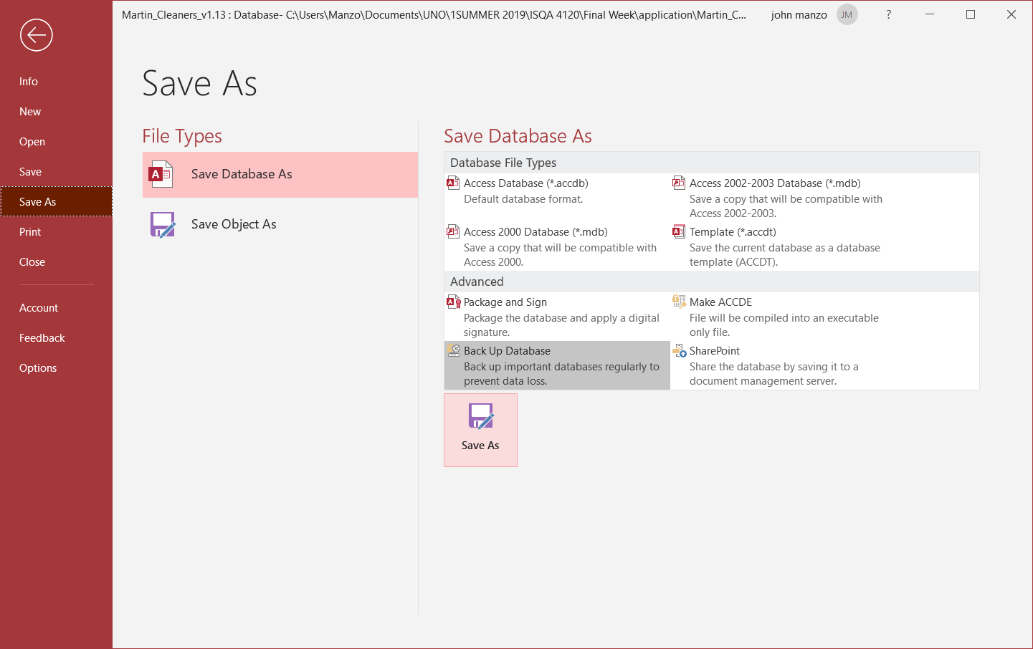  
*Figure 7: Creating a system backup*

Next, upload this file to an off-site location; [Google Drive](https://www.google.com/drive) is a free, reliable choice.

To recover from a system failure or data loss, download the latest backed up file, open it to ensure its integrity, then delete the damaged application file. The backed up file is now the new main application file.

In the event the Microsoft Access installation becomes damaged or unstable, reinstall MS Access from the provided installation disk using the steps described in Appendix A.

If the system needs to be relocated to another Windows 10 PC, make and upload a new backup file of the system, install MS Access on the new computer, then download the backed-up file to use as the application on the new computer.